**IOS Game Application “Keep Your Love” Development Report**



Nanjing Xiaozhuang university (南京晓庄学院)

+86 15151826876

Created By

Amelia Esra Sihombing ( 艾 美 丽)

On January 6th, 2019

**Developing “Keep Your Love” IOS Game Application using Xcode 10**

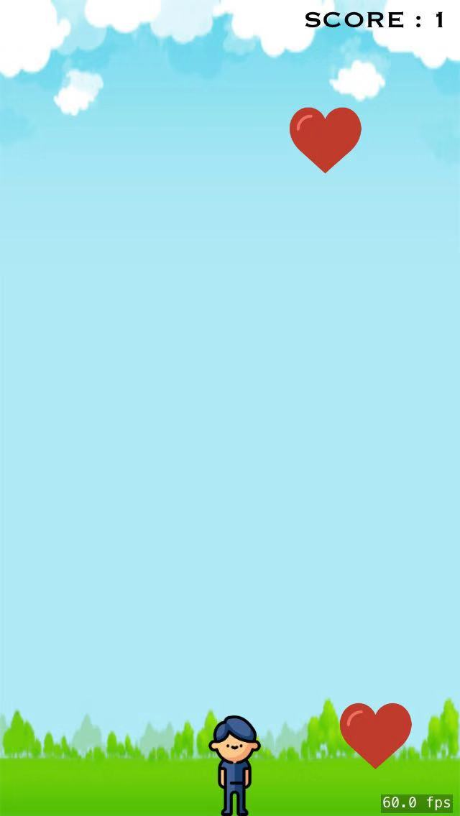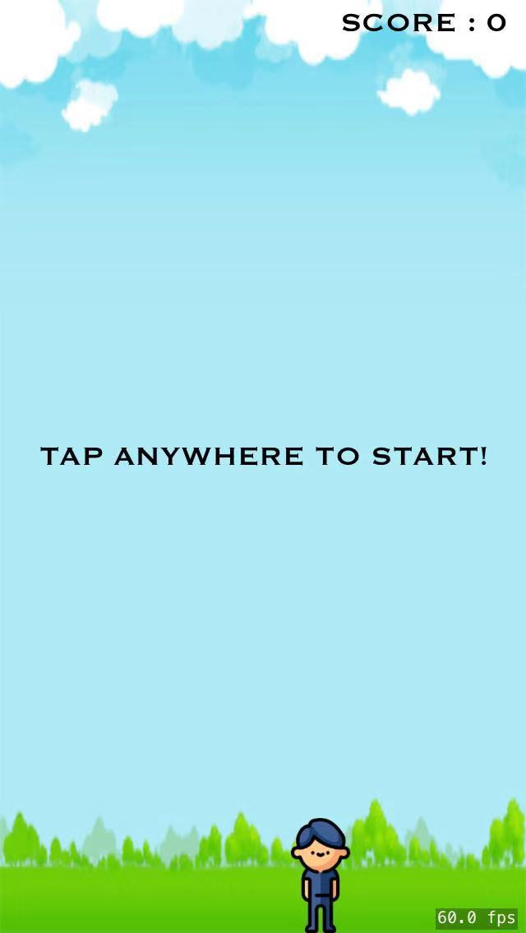

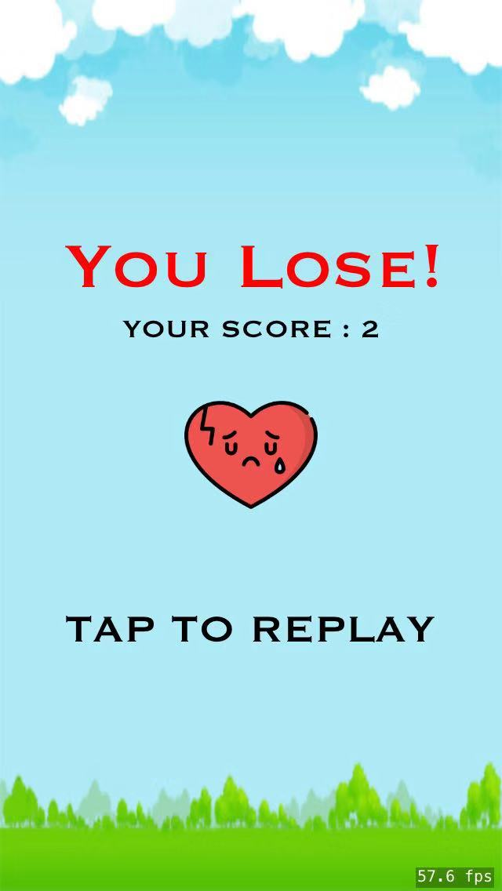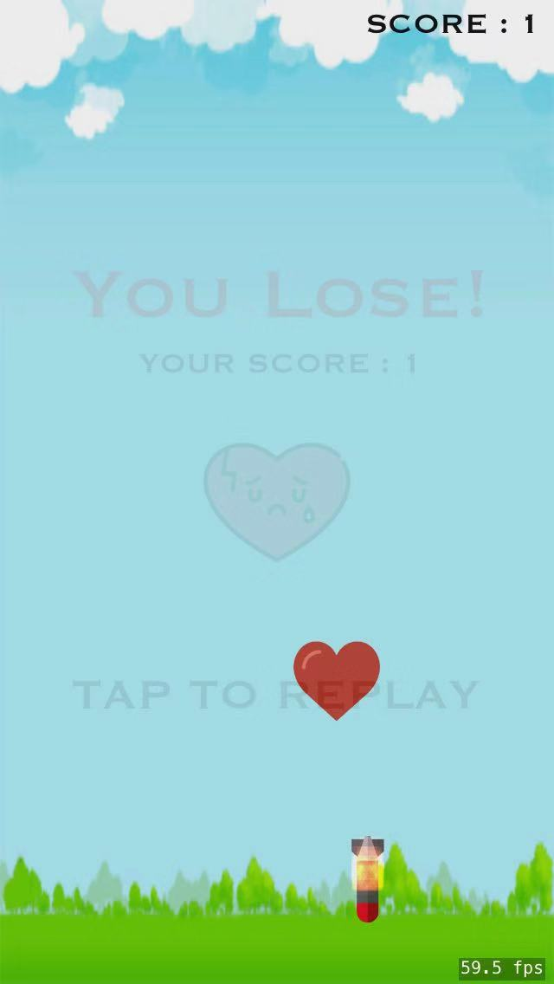

*Figure 1 - Keep Your Love Game Application*

Keep Your Love game is a game where the player (man) try to collide with the love object, and avoid colliding with torpedo object, which it will appear suddenly and fast. When the player got collide with the love object, score will be added 1, and if the player got collide with the torpedo object, game over result will be displayed. After that, player can replay the game by tapping screen. This application is developed using Swift programming language in Xcode 10. These are detail steps and code about Keep Your Love Game App.

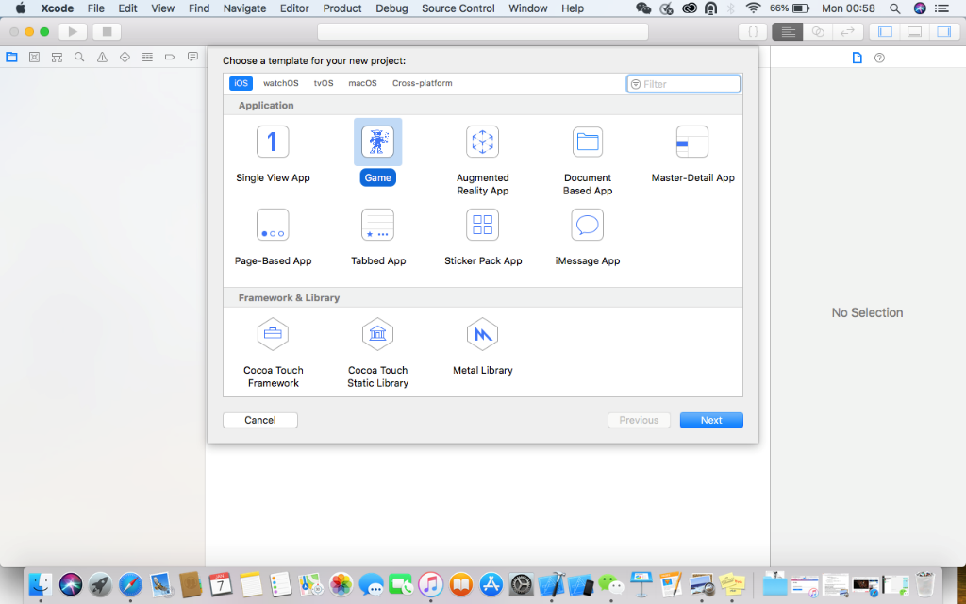

*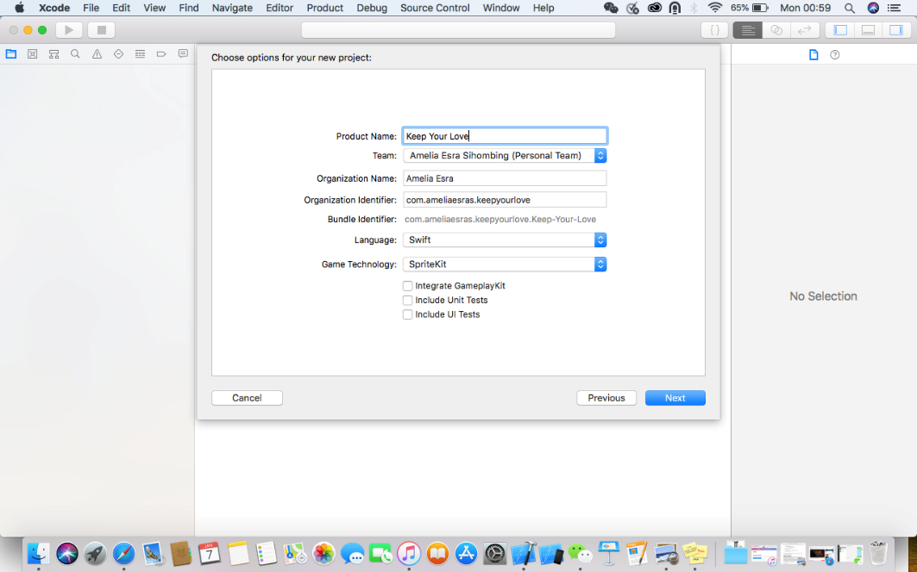Figure 2 – Create New Game Project IOS in Xcode*

*Figure 3 – Create Project Name and Developer team*

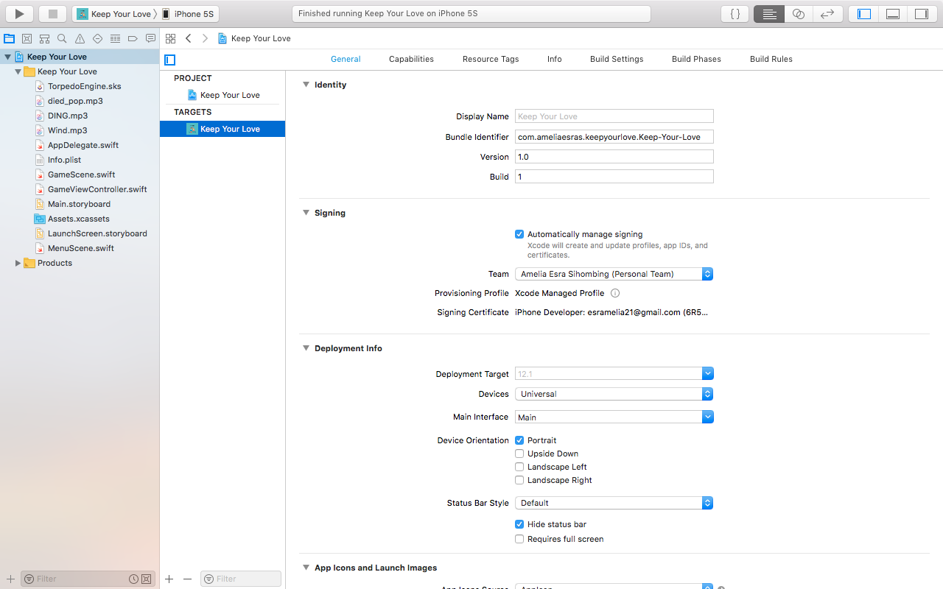In *Figure 3* we should familiar with ***Product Name*** (name of the application), ***Team*** (if we are a personal / team developer, we could input our account in here, it is like identity for whom developer that build this application), ***Organization Name*** (name of personal or team developer), ***Organization Identifier*** (unique URL for our game application), ***Language***, and ***Game Technology*** (*SpriteKit* [High level 2D Framework], *SceneKit* [High level 3D Framework], *Metal* [Low level 3D graphics API]).

*Figure 4 – General information about the application*

I use my iPhone to test running this application, and I should signing using my email account / Apple ID, and then verify the application in my iPhone, after that the application will be installed.

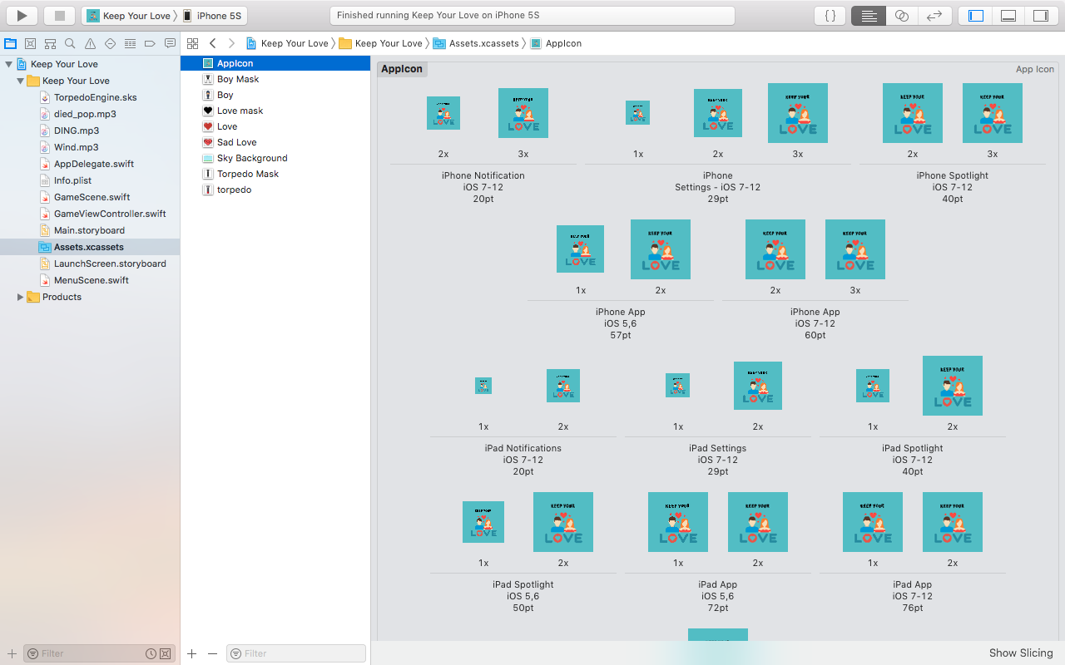

*Figure 5 – Image Assets*

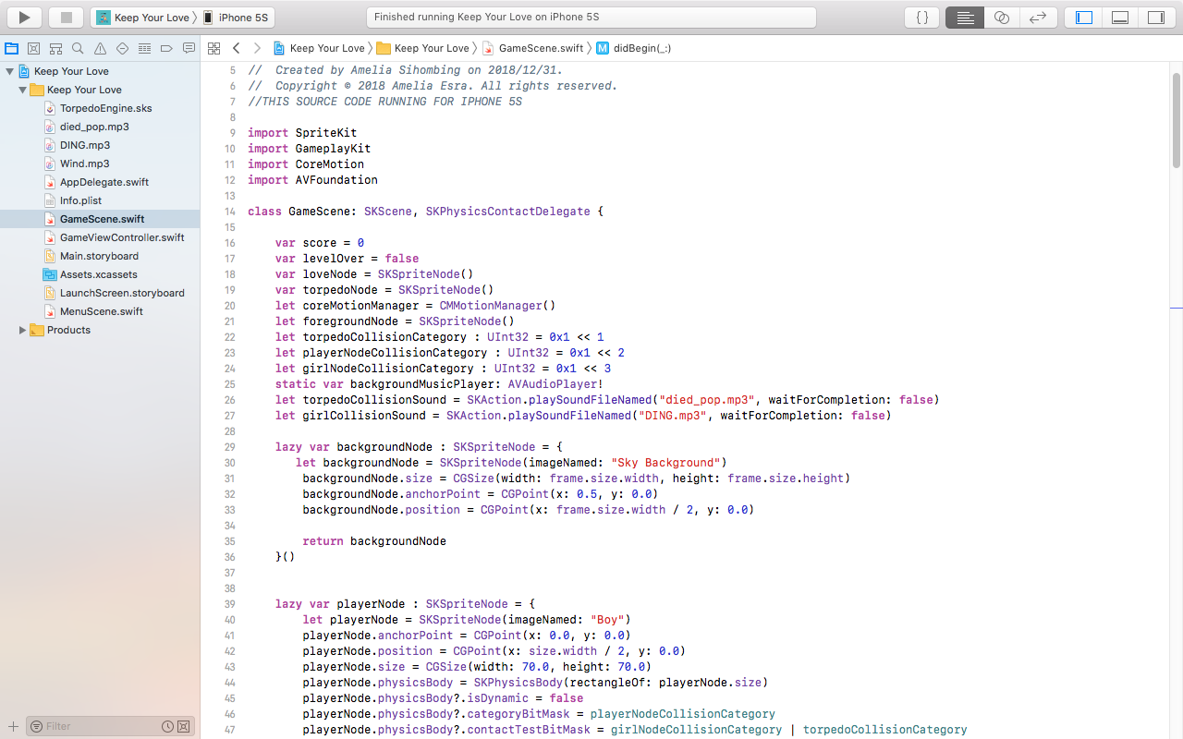I use appicon.co website to generate my App Icon to suitable in all types of iPhone and iPad, also this website can use to generate images into 3x pixel size in IOS, Android, etc.

Setting the player image and declare the physicsBody of the player to get collision

Setting the background image

Declaration statements of variables that will run in this application

These are frameworks that provide the required infrastructure for this game

In GameScene, I create some functions :

* BackgroundNode 🡺 which will display background image of the application
* PlayerNode 🡺 which declare about the player with the physicsBody to get contact to the other nodes
* ScoreTextNode 🡺 which display text of score in the right corner of the screen
* PlayTextNode 🡺 which will display text to start the game in the center of screen / frame
* Random function 🡺 get random value to setting the random position of loveNode and torpedoNode
* SpawnLoveNode 🡺 setting loveNode position and action
* SpawnTorpedoNode 🡺 setting torpedoNode position and action
* TouchesBegan 🡺 setting action every time the user tap the screen / frame of this game
* GameOverWithResult 🡺 setting function to call the MenuScene and to display a new scene to replay the game
* SeUpBackgroundSound 🡺 to setting a continuously music/sound of the background
* DidSimulatePhysics 🡺 to setting the accelerometer action of the player and to setting the position of the player when the accelerometer is on
* DidBegin function 🡺 to setting the begin action of this game
* Update function 🡺 to update the new game scene with conditions

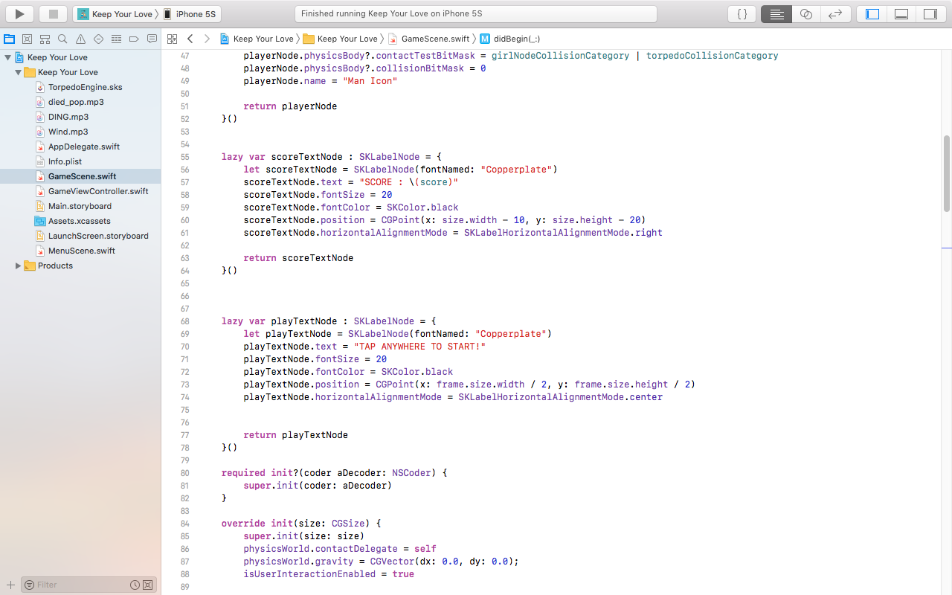

To setting gravity, and user’s interaction with the game

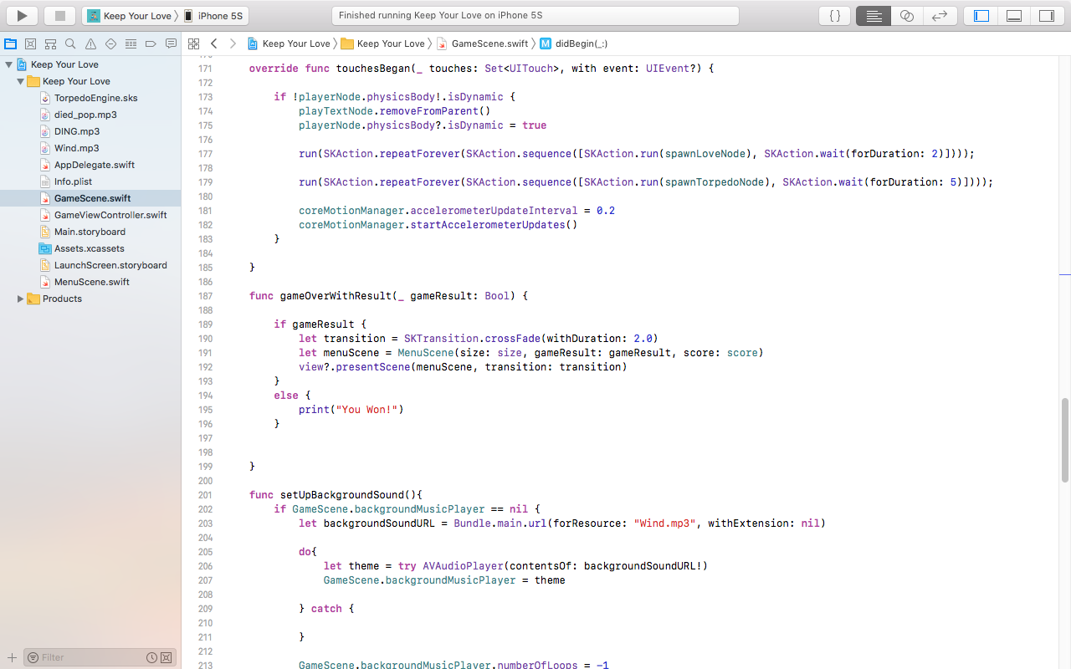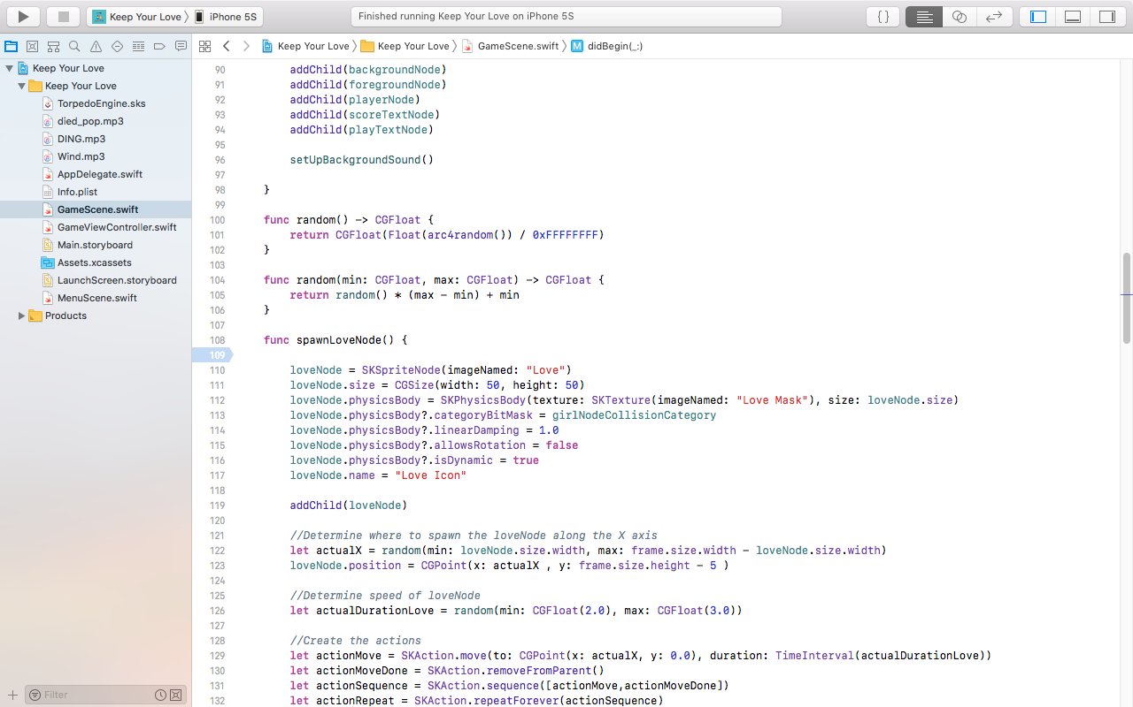

Setting position and actions of loveNode

To get random value to setting the position of loveNode and torpedoNode

Called the node functions into the scene

I use touchesBegan function to setting the accelerometer of player, and also to setting the time speed of producing the loveNode and torpedoNode. In gameOverWithResult I create 2 conditions, the first one is for condition if the player lose and will display the MenuScene.swift, and the second condition if player win.

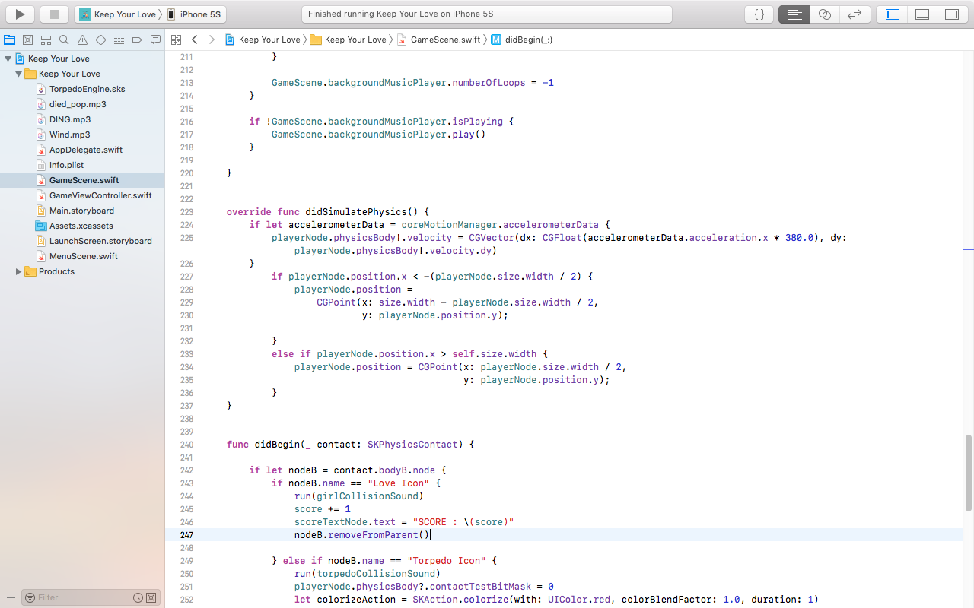

This code will put the score value into scoreTextNode, whch will be displayed in the right corner of scene

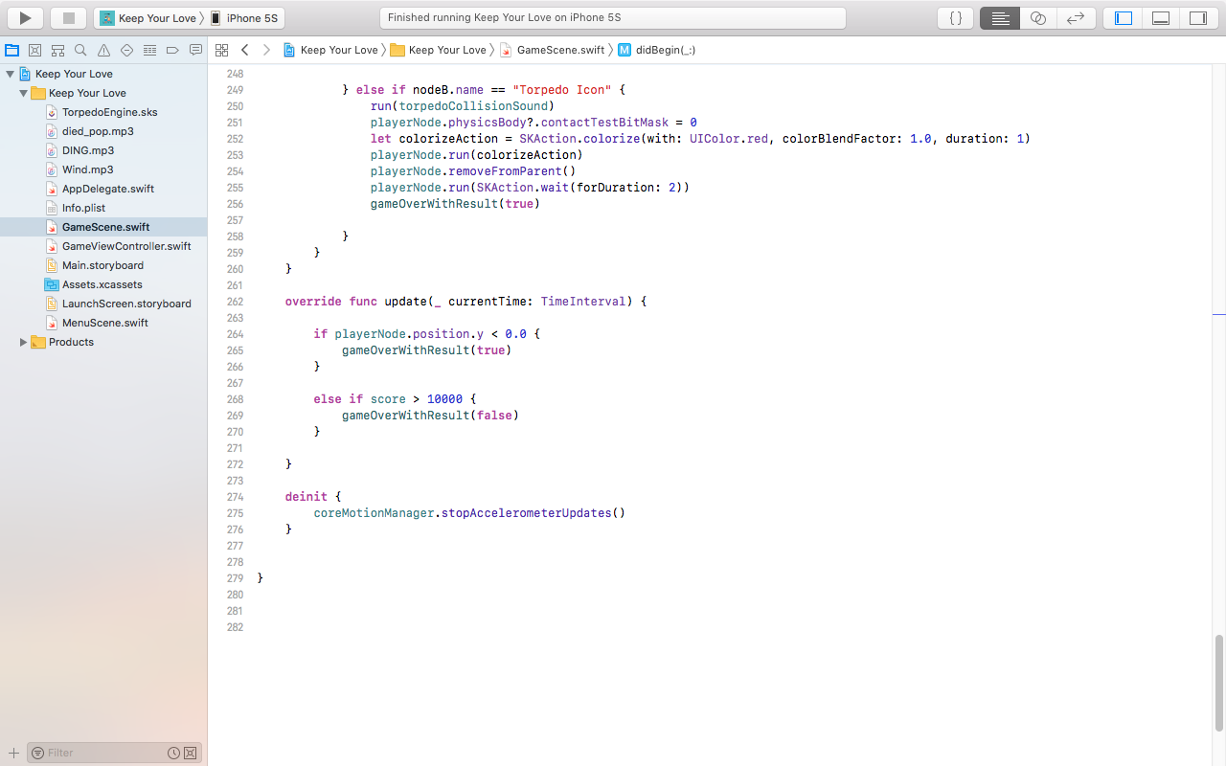

This else if condition will executed if the player collide with torpedoNode

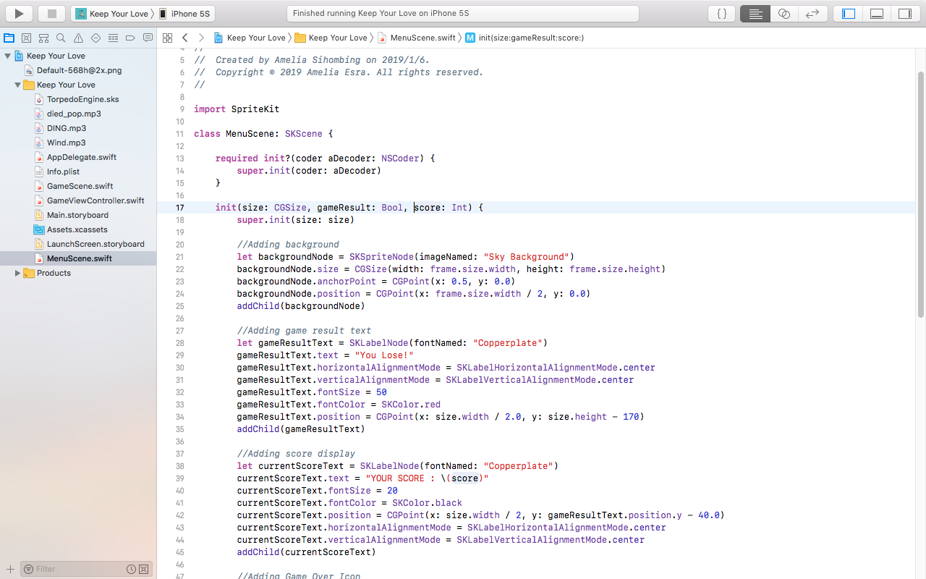

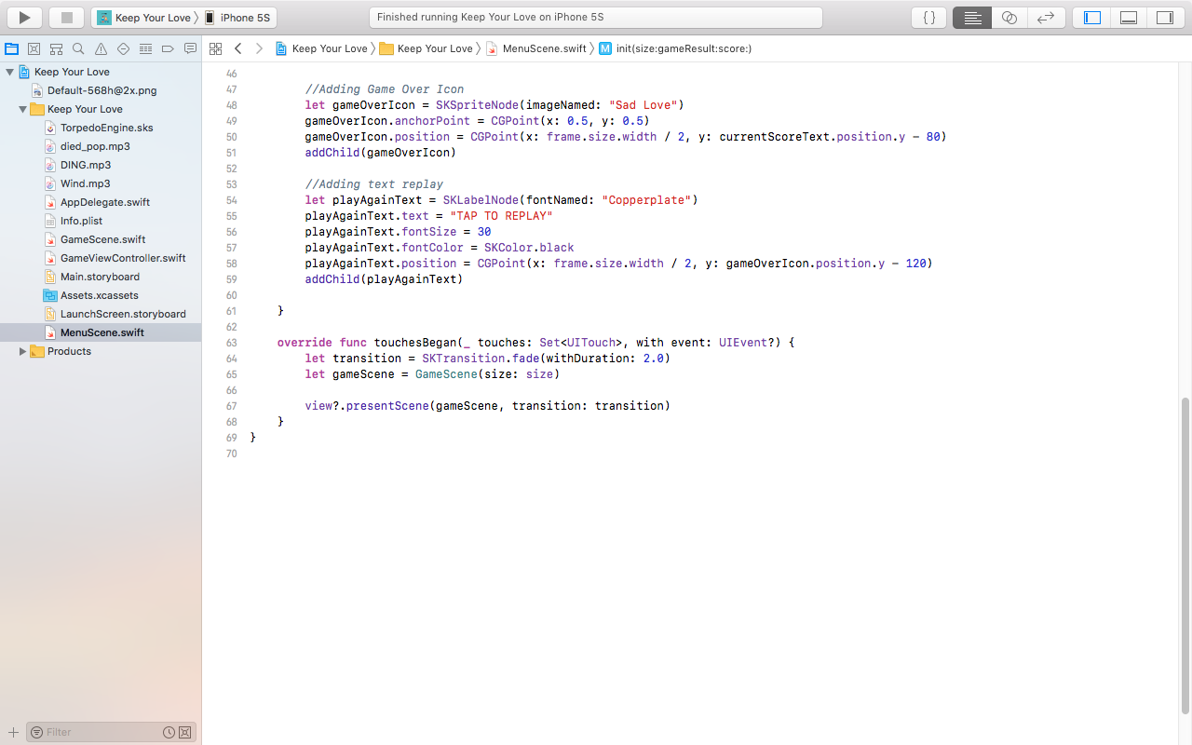

MenuScene.swift to display the Game Over result of this game using transition into another scene. In MenuScene.swift, I create some lazy variable to display text, and touchesBegan function will execute everytime user touch the scene and function inside the touchesBegan will replay the game.